We are All Treaty People.  Land Acknowledgments of the unceded Mi’kma’ki territories, |  |  |  | Teaching & Learning Centre | St.Fx.|  We are All Treaty People.
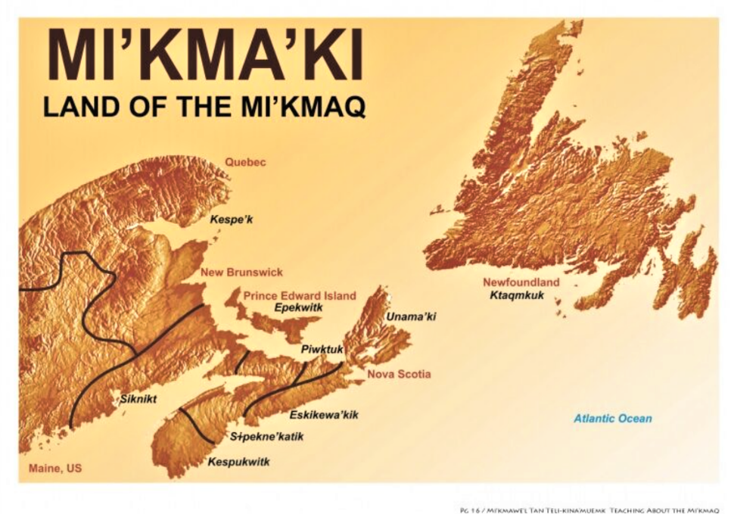  Nova Scotia Land Acknowledgment:  We would like to begin by acknowledging that we are in Mi’kma’ki, the ancestral and unceded territory of the Mi’kmaq People. This territory is covered by the “Treaties of Peace and Friendship” which Mi’kmaq and Wolastoqiyik (Maliseet) Peoples first signed with the British Crown in 1725. The treaties did not deal with surrender of lands and resources but in fact recognized Mi’kmaq and Wolastoqiyik (Maliseet) title and established the rules for what was to be an ongoing relationship between nations. |  |  |  | Terminology  Unceded Lands  Territories or lands that First Nations people never ceded/surrendered or legally signed away to the Crown or to Canada.  Peace & Friendship Treaties:  Treaties signed in the Maritimes between 1725 and 1779 intented to end hostilities & encourage co-operation between the British & Mi’kmaq and Maliseet First Nations. The Treaty of Peace & Friendship covers all territories within Mi’kma’ki.  Territories included:  all of Nova Scotia and Prince Edward Edward Island, New Brunswick (North of the Saint John River), the Gaspe of Quebec, and parts of the State of Maine and part of Newfoundland

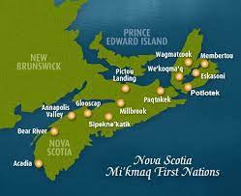
Culturally Respectful Acknowledgement of Mi’kmaw Territory in Nova Scotia. This does not include full area of unceeded territories.
Dalhousie ISAP Mural
the Agricultural Campus’s new Indigenous Student Access Pathway (ISAP)
Art source Designed by Art Stevens,
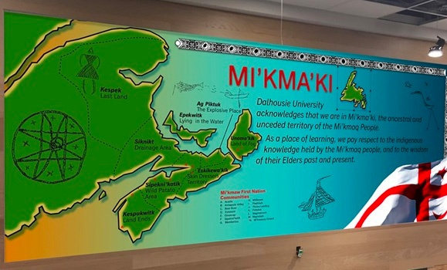
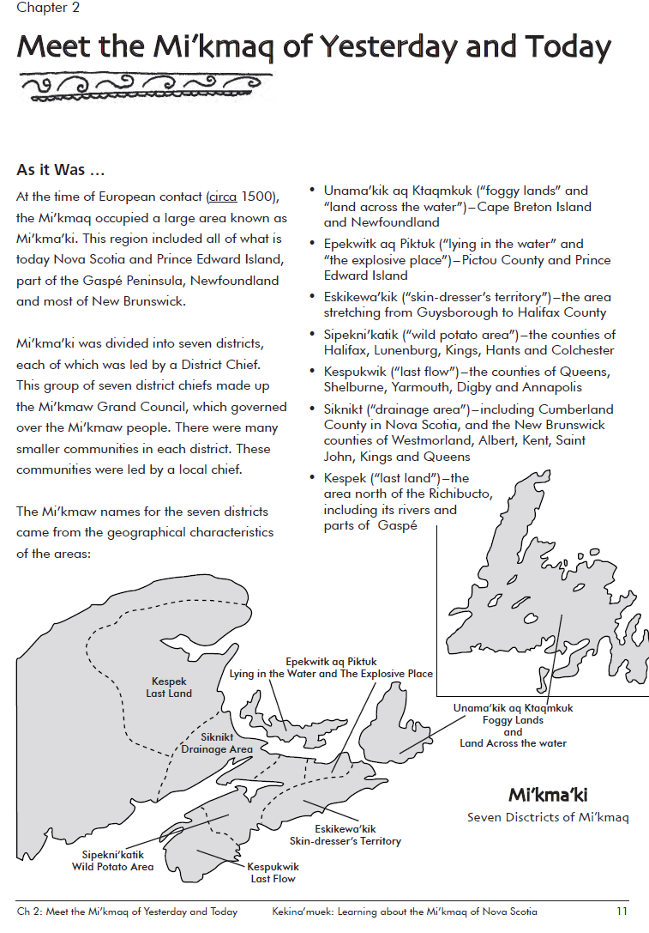

Land Acknowledgment: Their importance.
The importance of delivering land acknowledgments is to understand that the land that we reside on is. It is important to recognize the land we

Why do we recognize the land?
To recognize the land is an expression of gratitude and appreciation to those whose territory we currently reside on. It is a way of honoring the Indigenous people who have been living and working on the land from time immemorial. It is important to understand the long standing history that has brought you to reside on the land, and to seek to understand your place within that history. Land acknowledgments do not exist in a past tense, or historical context: colonialism is a current ongoing process, and we need to build our mindfulness of our present participation. It is also worth noting that acknowledging the land is Indigenous protocol.

Things to remember when delivering a Land Acknowledgment.

- Using apporpriate language. Use terms that are not sugar coated. For example, genocide, stolen land, forced removal of Mi’kmaq peoples.

- Use past present and future tenses. We as First Nations peoples are here, have been here, and always will be here. We are thriving and not just people of the past.

- Do not ask indigenous students/facualties to deliver a welcome statement. Land acknowledgements are provvided to recognize and educate. They are imporant to have and are not meant to be used as a happy proud welcoming. With that being said, it is important to keep in mind that having an Indidenous person be expected to deliver a land acknowledgement puts them onto the front lines. Sacrificing their emotion and vulnerability. A land acknowledgment being delivered or expected to be delivered by an indigenous person is like expecting them to share the story of their peoples loss while giving people the gain of that education.

- How to talk about Native Nations: A Guide.

